In week 10, we made a lot of progress on finalizing the project content. We started adding final UI into the game and wrote scripts for our stretch goal story chapters (Chapters 7-10).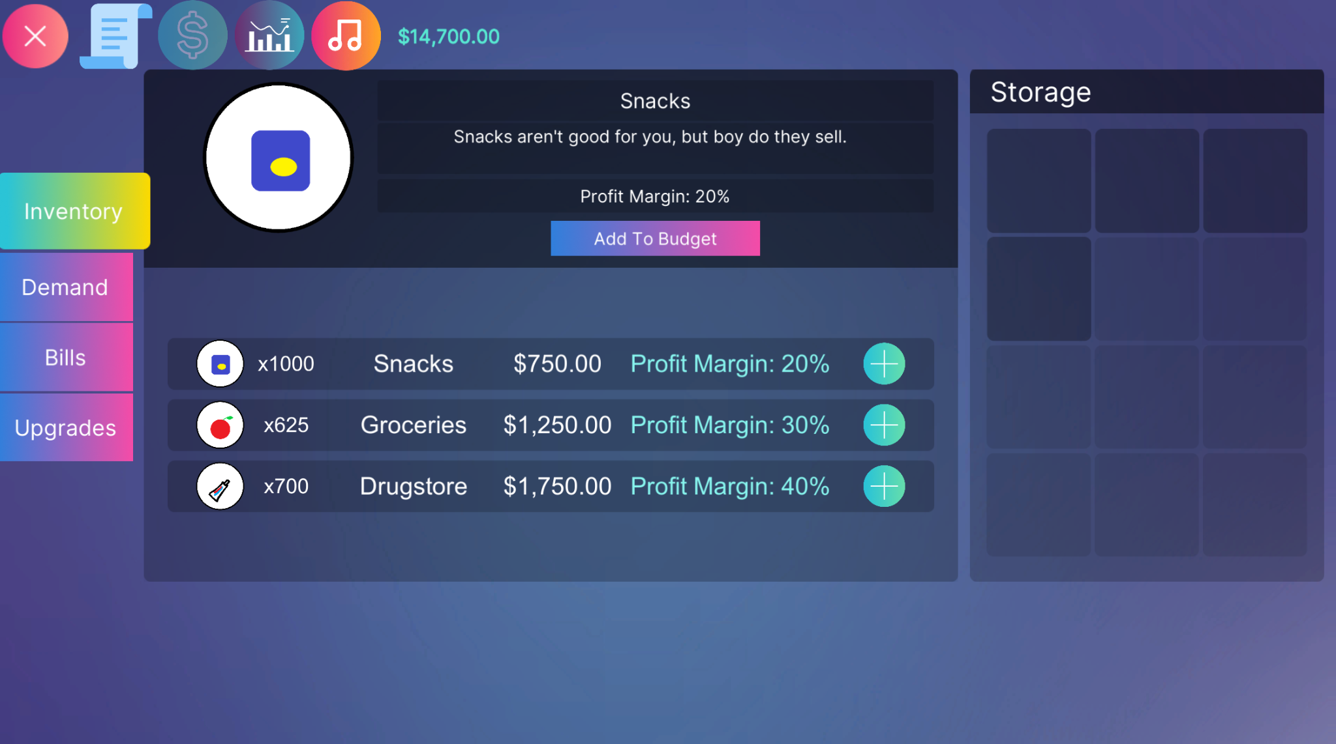

We also planned solutions to several issues. We need to ensure that our avatars resonate with the target demographic. The same goes for our UI - we discussed strategies with our advisors to add thematic consistency and interest to the UI and make it less generic. For example, we could use graffiti-themed details as a theme to tie it together. We are also replacing several found 3D models that don’t fit well with our theme - some assets seem like they belong in a supermarket instead of a bodega. For next week, we created a priority list for final features to complete:

**-Avatar selection**

**-Community donations**

**-Saving/loading**

**-Random events**